# Create a Mongo Database and User

1. Download a copy of this file and upload it to the root of your virtual machine via FTP.
2. Create a MongoDB and User  
   Using your SSH connection connect to your mongodb by typing:  
     
   mongo admin --username root --p [Bitnami root password]  
     
   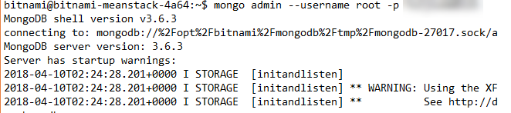
3. Type: “show dbs” to view the databases currently saved.  
     
   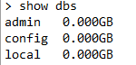
4. Create a new MongoDB by typing “use [new db name]”. For example, “use cis3801”  
     
   
5. Create a new user by typing “db.createUser( { user: “[place username here]”, pwd: “[place password here]”, roles: [ "readWrite", "dbAdmin" ]} )”  
     
   Then type “show users” to view new user.  
     
   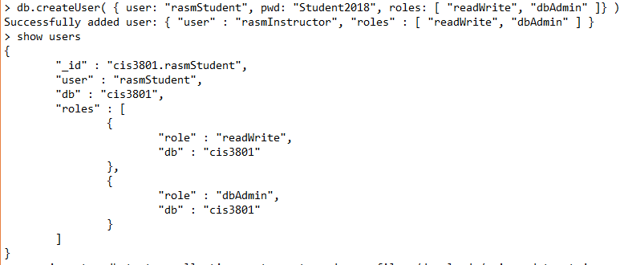
6. Type “exit” to exit Mongo shell.
7. Import the sample restaurants database by typing “mongoimport -u [your new MongoDB username] -p [Your MongoDB password] --db [your MongoDB name] --collection restaurants --drop --file ~/downloads/primer-dataset.json”  
     
   
8. Connect to Mongo again by typing   
     
   mongo admin --username root --p [Bitnami root password]  
     
   
9. Type “show dbs”, then “use [your database name]”, then “show collections”.  
     
   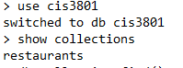
10. To view the contents of the restaurants collection, type “db.restaurants.find()”  
      
    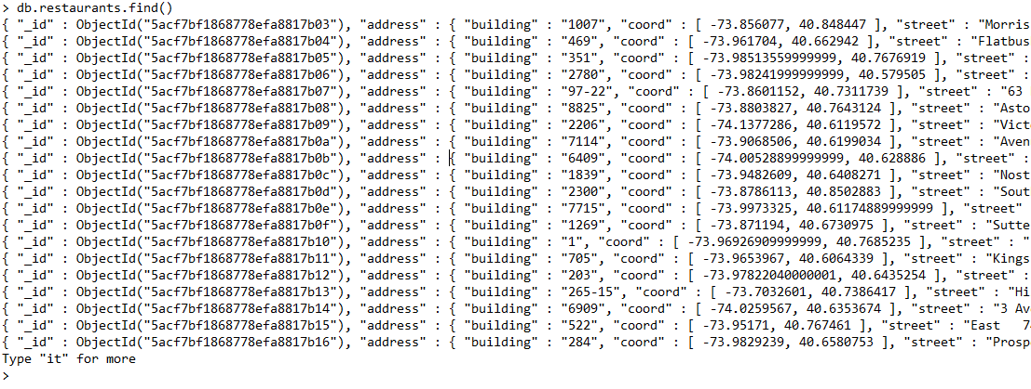
11. Your MongoDB URI will be:  
    mongodb:// [place username here]: [place password here]@localhost/cis3801